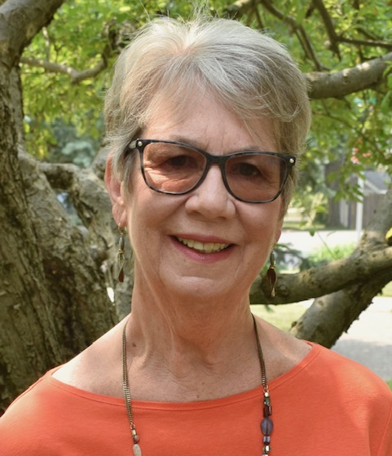
Message from Amy Kelly, newly elected FPNA Board President

Dear Foster Park Neighborhood Residents,

Hello new and old neighbors. Thank you to those of you have who have entrusted me to lead the 2023-2024 FPNA board. To those who are retiring from the board, we thank you for your service. And to the others who volunteered to be passed the baton, thanks for joining.
We have many things to be proud of in this historical neighborhood and it is my intention to continue the momentum that previous boards initiated. I agreed to volunteer for this role not to shoulder the responsibility on my own but to rely on all of you to participate and engage in the activities that strengthen our neighborhood.
We are all experiencing the pains of yet another road closure for the Mama Jo water project tunnel. A number of our neighbors and I have been in contact with various city departments as well as our City Council Representative, Geoff Paddock, seeking a quick resolution to the traffic snarls. Please contact me or Kody Tinnel if you have concerns or questions; we will forward on to the appropriate city personnel. In the meantime, stay patient and safe. There is a “light at the end of the tunnel”!!
I would like to invite all of you to attend our board meetings which are open to all. This is a wonderful way to introduce yourself to the governing body as well as to get vital information regarding adjacent neighborhood activity that affects us all. Stay informed and involved. We strive to be stronger.

Sincerely,

Amy Kelly | Board President
IN THIS ISSUE
Message from President 1
Neighborhood Walk 2
Construction Updates 2
Board of Directors 2
Board Meetings 2
Feedback 2
Annual Dues 3
Yard of the Month 3
Annual Dues 3
Committees 3
Street Tree Care 3
News & Updates 3
Packard 2030 Plan 3
Yard of the Month 4
Summer Reminders 4
Community Contacts 4
City Council Members 4
Rental Restriction 4
Street Lights 4


Photo credit | Lynn Fuston

HAVE YOU HEARD

Our neighborhood became part of new state legislative districts during the last round of redistricting. Our state representative is now Phil GiaQuinta and our state senator is Travis Holdman.

The Friendly Fox has new summer hours that include dinner until 8pm Tuesdays through Saturdays.
community news

Save the Date | Neighborhood Walk with City Councilman Geoff Paddock

Join us on Saturday, July 29th at 10:30am for a neighborhood walk with 5th District City Councilman Geoff Paddock. Plan to meet at Amy Kelly’s home – 1305 Sheridan Court.

If you have any specific issues, ideas, or requests, please send that information to Amy Kelly in advance so the most appropriate city staff can also be invitited to join us for the walk to share their expertise.

This is a great opportunity to speak directly with elected officials and city staff about topics in and around our neighborhood. Hope you can join us!

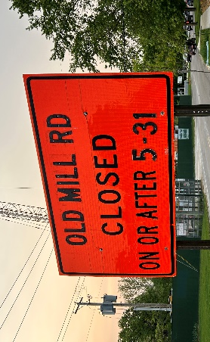
Construction Project Updates

It seems like construction never ends in and around our area. To help our residents make sense of everything, here is a quick run-down.

Old Mill Road Closure | Old Mill from Rudisill to West Foster was closed on May 31 and will remain closed for at least 10-12 weeks to allow for a sewer project that will connect recently completed projects in the nearby area. Neighborhood leaders have been in close contact with the city regarding ways to minimize negative consequences related to traffic and pedestrian safety.

Summit Campus Demolitions | The four vacant buildings at The Summit (formerly Taylor University) are slated to be demolished over the coming months. Per the campus management, VIA Development, “After much thoughtful consideration, it has been determined that the North Campus buildings and Hausser Hall on the South Campus will be taken down. Over the years, there has been countless hours and dollars spent with experts analyzing ways to save these structures, but ultimately it is not feasible.”

Foster Park Entrance | The Tunnel Works project should be completed and operational in 2025. The redesign of the park’s front entrance will follow completion of the work and the public will be consulted regarding the design.

Bluffton Road Bridge | Construction is set to begin in late winter or early spring of 2025 and last through the spring of 2026. Check out the News section of the FPNA website for more information.

Foster Park Golf Course | Following additional public input from the first proposed plan, Parks & Recreation is going back to the drawing board to revise the proposal to accommodate the feedback received.
BOARD OF DIRECTORS
July 2023 – June 2024

Amy Kelly | President
1305 Sheridan Ct.
amy.kelly01@icloud.com

Oscar Matter | Vice President
1302 W. Branning Ave.
o.w.matter@protonmail.com

Ken Sorg | Treasurer
1231 W. Branning Ave.
kennethesorg@gmail.com

Becky Allegrini | Secretary
1147 Sheridan Ct.
rebeccaj.allegrini@gmail.com

Cory Allen
1310 W. Foster Pkwy
allencory@hotmail.com

Emily Ewing
1230 W. Lexington Ave.
Emilyewing0318@gmail.com

Lynn Fuston
1202 W. Branning Ave.
lynnfuston@gmail.com

Connie Hazelrigg
1322 W. Foster Pkwy
chazelrigg@comcast.net

Andrea Thomas
4001 Old Milld Rd.
dortchthomas@gmail.com

BOARD MEETINGS

The Board of Directors will meet on the following upcoming dates:
Tuesday, July 25, 2023
Tuesday, October 24, 2023
Tuesday, January 23, 2024
Tuesday, April 23, 2024

Meetings begin at 6:00pm and are typically held in the Learning Center on the Summit campus (1025 W. Rudisill). All residents are welcome to attend.

FEEDBACK

Have an idea? A question? A concern? Feel free to contact the board to share your thoughts and feedback. We are eager to hear from residents and provide support and help when we can!
around the neighborhood

2023-2024 Annual Dues

We are now collecting dues for the 2023-2024 fiscal year, which runs from July 1, 2023 through June 30, 2024. The modest $50 per household dues help provide a range of services and value to the neighborhood, including street tree plantings, light pole banners, website, social events, and membership in the Southwest Area Partnership and the Packard Area Planning Alliance, among others.

You can easily submit your membership dues online at www.fosterpark.org/dues or by scanning the QR code to the right. All major credit cards are accepted via the PayPal payment portal and a PayPal account is not required.

Payment by check (made payable to FPNA) can be mailed to:
Ken Sorg | FPNA Treasurer
1231 W. Branning Ave.
Fort Wayne, IN 46807

Thanks for supporting a strong and vibrant Foster Park Neighborhood!

Committees

The association is always looking for residents interested in sharing their time and talent to benefit the neighborhood. One way to get involved is by joining one of the different committees that operate for specific functions. Details about each committee are below. Be sure to contact the board if you are interested in learning more or getting looped in with one of these committees.

Yard of the Month Committee | This group nominates and votes on gardens for our Yard of the Month award program that runs from May through October(ish). This is a good excuse to go on walks around the neighborhood and a fun way to meet neighbors.

Social Committee | This group plans and implements social events for the neighborhood, such as our annual Cider and Donuts block party event in October and any other ideas that may arise.

Beautification Committee (coming soon) | Though not yet up and running, we are seeking residents interested in helping ensure our neighborhood is looking its best, including in areas like the Sheridan Court center park strip. This may include volunteering some time for gardening upkeep, helping write grant requests, or anything else that helps keep our neighborhood looking great.
STREET TREE CARE

Over the past few years, our neighborhood streets have gained nearly 60 new street trees. To ensure they grow to full maturity, please take a few steps to support the health of these young trees.

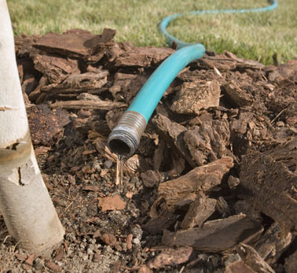

Water | This is the most important element of caring for newer trees, especially during the summer. Water at least once a week in the hot, dry months to promote stronger roots.

Mulch | Spread a 2-inch layer of natural mulch under the drip line of the tree. This helps maintain soil moisture, prevent weeds, and prevent possible damage from lawn equipment. Avoid piling excessive mulch around the base of the trunk.

NEWS & UPDATES

Keep up to date with what’s happening in our neighborhood and the surrounding area.

Website | www.fosterpark.org

Facebook @FosterParkNeighborhoodAssociation

PACKARD 2030 PLAN

Following three years of community input and collaboration between neighborhoods, city planners, and key local stakeholders, Fort Wayne City Council voted unanimously to adopt the Packard 2030 plan.

Visit www.packardplan.org to learn more about the plan and why it matters for our neighborhood.
good to know

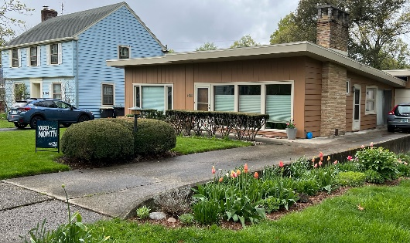
Yard of the Month

Congratulations to the first two winners of our Yard of the Month recognition program for 2023!

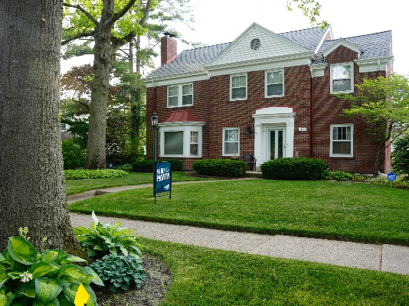
Our May winner (top) Pam does a wonderful job with her landscaping and brings a splash of color each spring to West Lexington.

Our June winners (bottom) are the Moellering Family. Their beautiful home on Branning is surrounded by an immaculate landscape.

Winners are nominated and voted on by the volunteer Yard of the Month Committee. Homes may win no more than once every three years. Contact Lynn Fuston if you’d like to nominate a neighbor.

Summer Reminders

Summer is here, so it’s a good time to share some helpful reminders to ensure we all have a safe and enjoyable season.

Safe Driving | Please drive carefully and watch for pedestrians, especially when backing out of driveways.

Tall Grass | Please keep your lawn mowed below 9 inches to ensure compliance with Fort Wayne’s tall grass ordinance. Be sure to also keep control of noxious weeds, like thistles, that can quickly take over.

Fireworks | Per local and state laws, fireworks may only be discharged on certain dates and times (see City website for details). Please be courteous to neighbors who may have pets or family members who do not react well to the sounds and lights from fireworks.

Pet Cleanup | Please make sure to clean up after your dog(s) when taking them on walks throughout the neighborhood.

Firepits | The use of firepits is permitted but subject to various safety conditions listed on the Fire Department’s website. Please reference those conditions to ensure compliance and take common sense steps to keep your backyard fires safe and controlled.

Security | We encourage all residents to take basic steps to reduce your likelihood of being targeted by a criminal. Plenty of helpful resources are available on the Fort Wayne Police Department’s website.
COMMUNITY CONTACTS

FPNA Board President
Amy Kelly
fostrparkneighborhood@gmail.com
260.414.8554

Fort Wayne Police Department
Non-Emergency Desk
260.427.1222

City Government Services
311

Essential Community Services
211

Graffiti Hotline
260.449.4747

CITY COUNCIL MEMBERS

Geoff Paddock – District 5
geoffreypaddock@aol.com
260.432.5700

Michelle Chambers – At-Large
michelle.chambers@cityoffortwayne.org
260.427.1445

Tom Freistroffer – At-Large
freistrofferatlarge@gmail.com
260.704.4229

Glynn Hines – At-Large
glynnhines@aol.com
260.447.7144

RENTAL RESTRICTION

As a reminder, renting is not allowed within the Foster Park Neighborhood Association boundaries without board approval (per our Restrictive Covenants, as amended in 2005). If you are currently renting or have questions, please contact the board president to learn more and initiate the formal approval process.

STREET LIGHTS

If you see a street light out in our neighborhood, please report it to the city via 311 (via phone or online). It is helpful to write down the pole number, which starts with a ‘K’ and is listed on yellow tags on the pole itself. Thanks for doing your part to keep our lights on!

